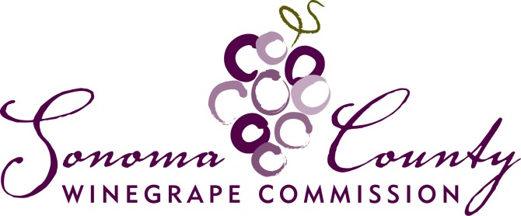

August 1st, 2022

Dear Vintner,

Sonoma County Winegrape Commission Crush District 3 will continue to invest over $2,000,000/year of grape grower dollars to promote Sonoma and Marin counties, our grapes and your wines. You support the facilitation and collection of these funds by withholding the grape assessment from your grower payments and forwarding those assessments to the Commission. We thank you for your continued support and cooperation!
For the 2022 vintage the Commission is maintaining the assessment rate at 0.0065 of the gross dollar value of District 3 winegrapes sold by growers to vintners. A vintner/purchaser of District 3 winegrapes is obligated by California law to withhold an assessment. Once the assessments are withheld from payments to the growers, the vintner holds the assessments in trust until remitted to the Commission by January 10th, 2023. Assessments are only withheld on grapes purchased from a non-related entity or from District 3 growers who commercially sell more than 25 tons of winegrapes, however, the assessment may still be submitted on a voluntary basis to support our programs and marketing. Please remember that the Sonoma County Winegrape Commission Assessment is not the CDFA Pierce’s Disease payment and must be paid separately if applicable.
In order to simplify the process of remitting grower assessments, the Commission has set a single reporting/payment deadline for the 2022-2023 marketing season on January 10th, 2023. Please remit the assessment report forms and payment no later than January 10th, 2023. Excel reports should be emailed to: assessments@sonomawinegrape.org. Please request an Excel spreadsheet for recording your information or download from our website at https://sonomawinegrape.org/growers/assessment-harvest/. Payments should be mailed to Sonoma County Winegrape Commission (SCWC), 3245 Guerneville Road, Santa Rosa, CA 95401. Please update your records to reflect our new address.
Reports and payments not submitted in a timely manner to the Commission are subject to a statutory late penalty of 10% and interest at the rate of 1.5% per month to be paid by the winery. Wineries are required to collect and remit the assessments.

All information provided to the Commission is confidential and will only be seen by authorized Commission staff. Please do not hesitate to contact Jennifer Richards, VP Operations and Business Development, at jennifer@sonomawinegrape.org or via phone at 707.522.5867 should you have any questions.
The Commission is committed to working with our wineries and local grape growers to increase the value of Sonoma County grapes and wines and to preserve our agricultural resource for future generations. Thank you for your support of the Sonoma County Winegrape Commission and for the 1,800 vineyard owners that we represent.

Sincerely,

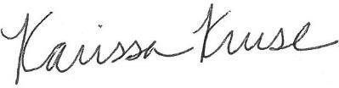

Karissa Kruse
President, Sonoma County Winegrape Commission

